Bootstrap Grid System

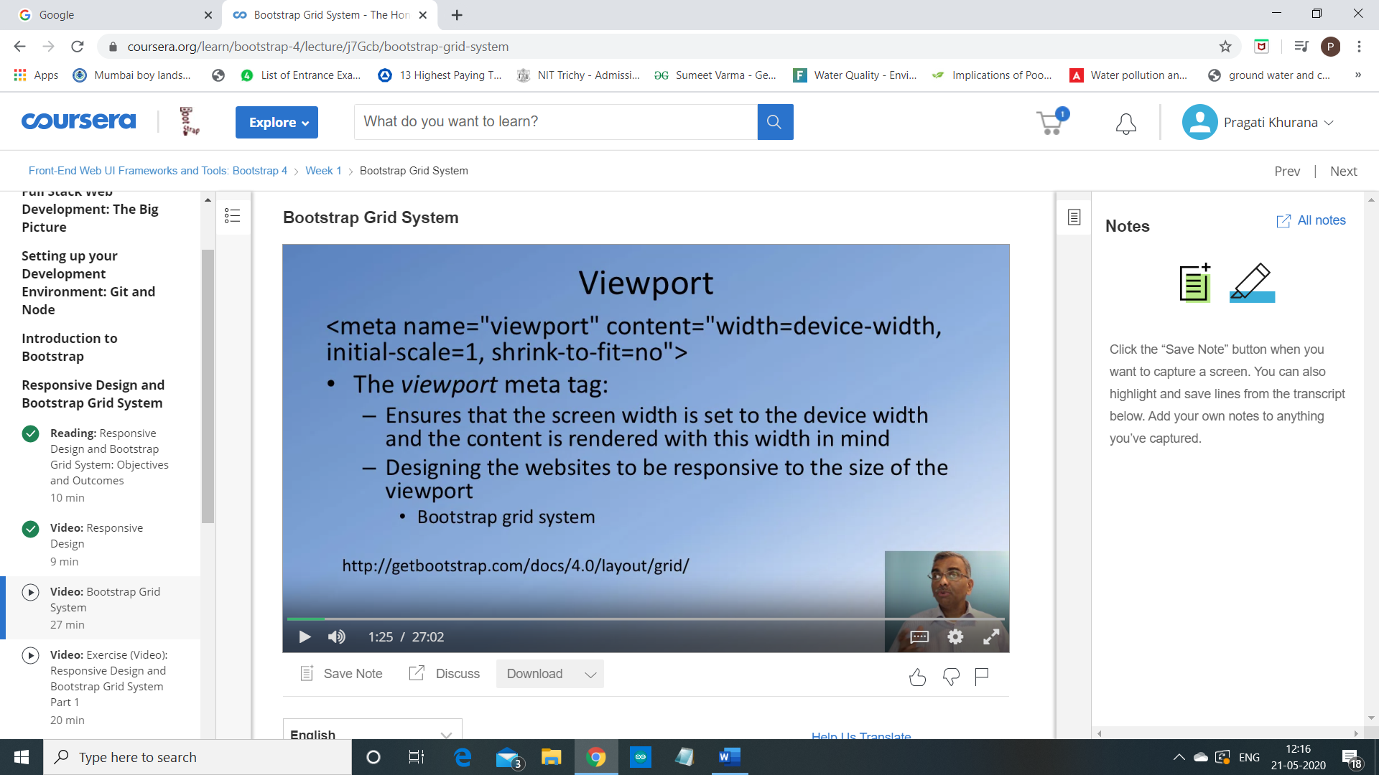

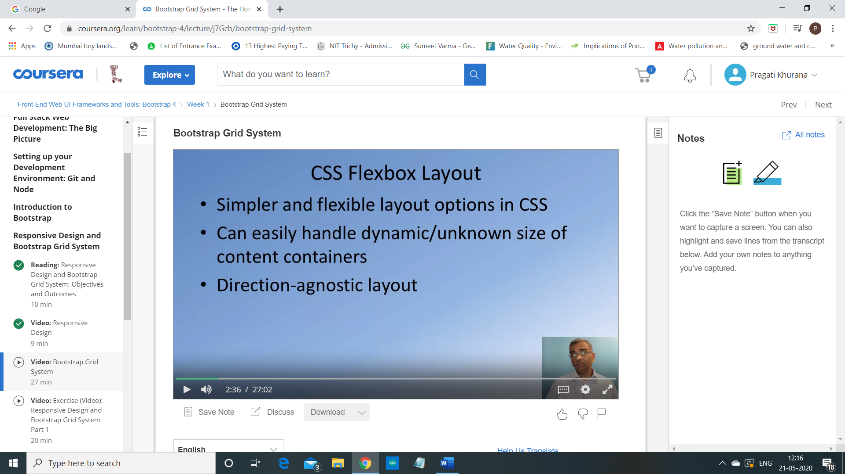

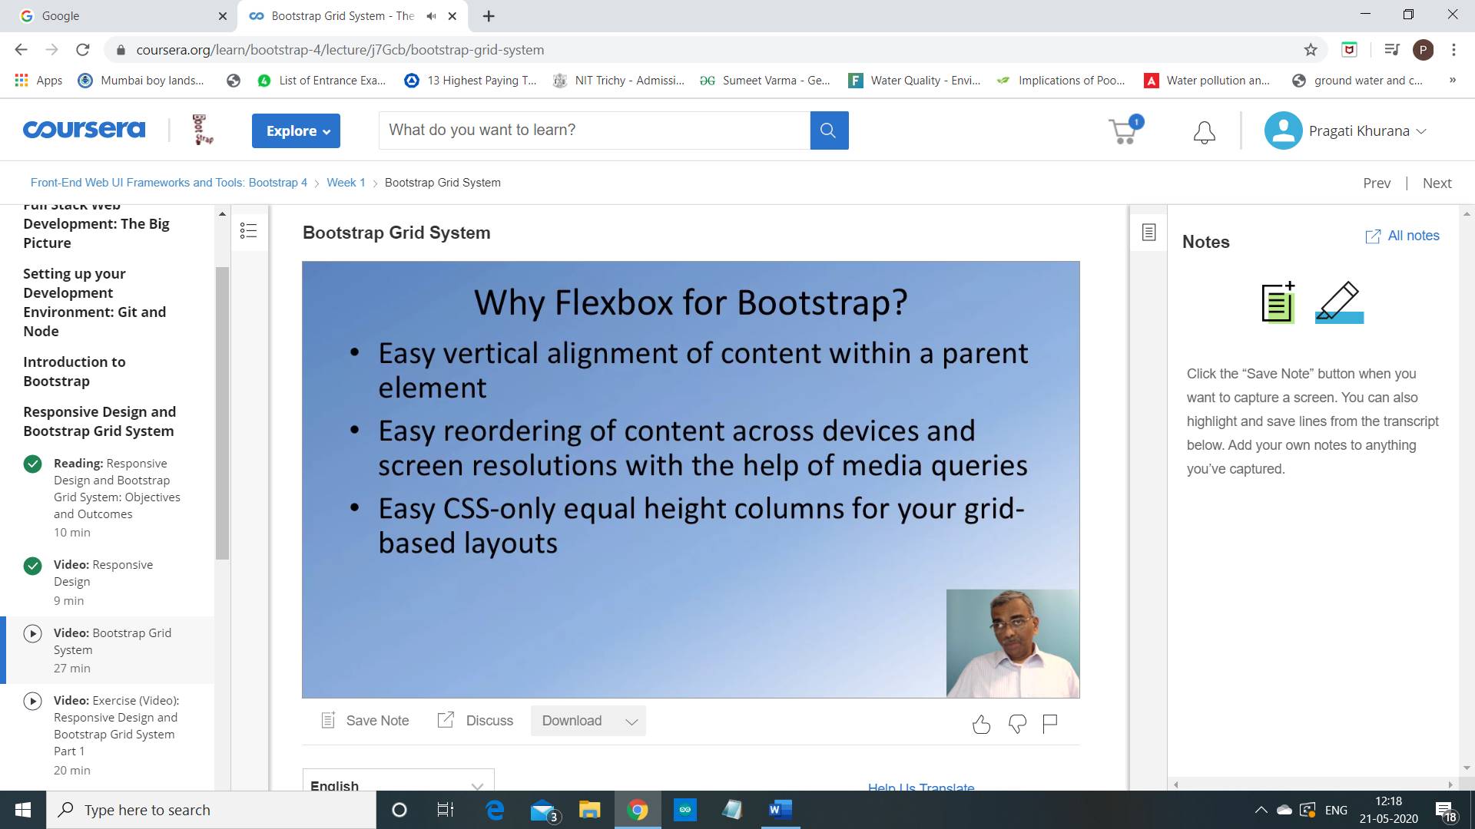

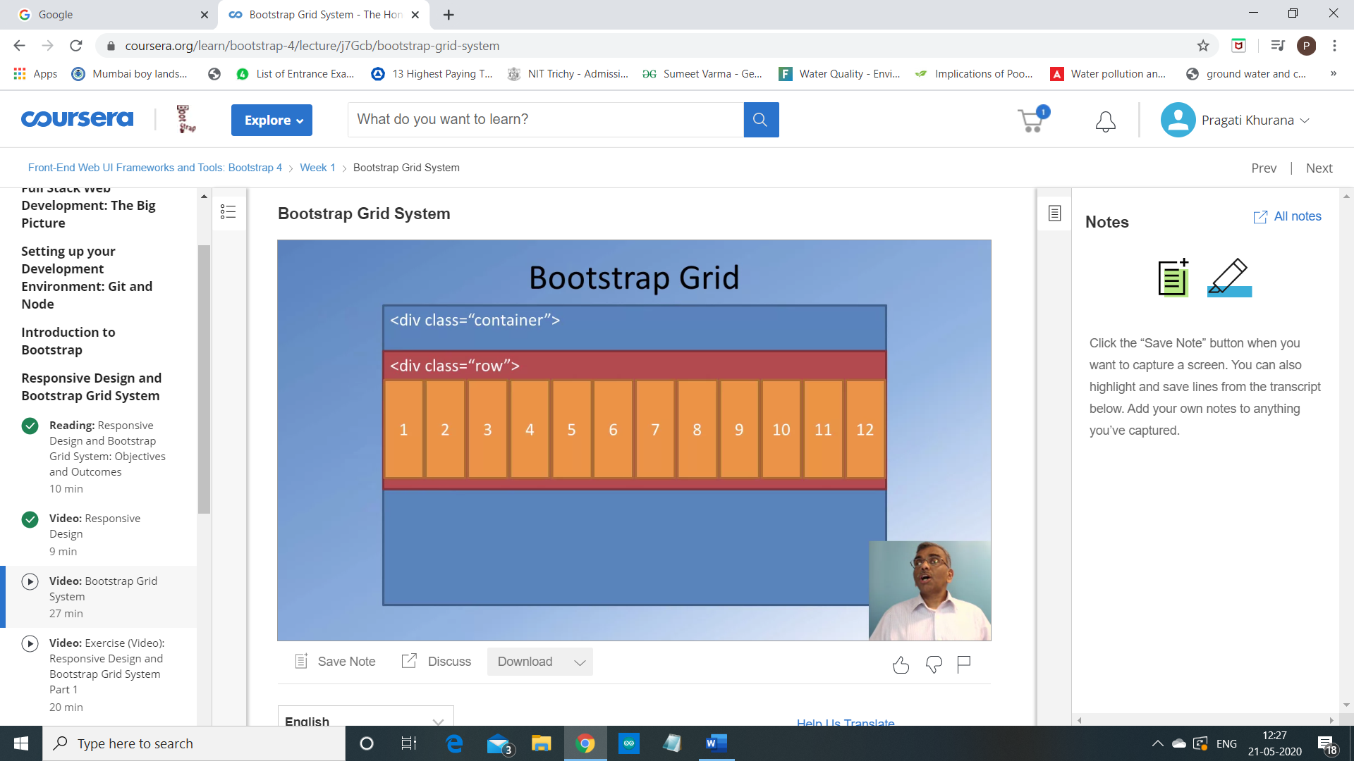

So, and the fact that the content itself adapts to

the screen width and the row itself being

enclosed inside the container will automatically adapt to the screen width,

and also the columns,

the 12 columns will be determined.

Their widths will be determined by the row by itself.

So, which means that for a different screen sizes,

whatever content you layout all of those 12 columns will automatically adjust

itself to the width that is allowed for the content.

So, this is how the responsiveness is built

into the Bootstrap grid way of laying out the content.

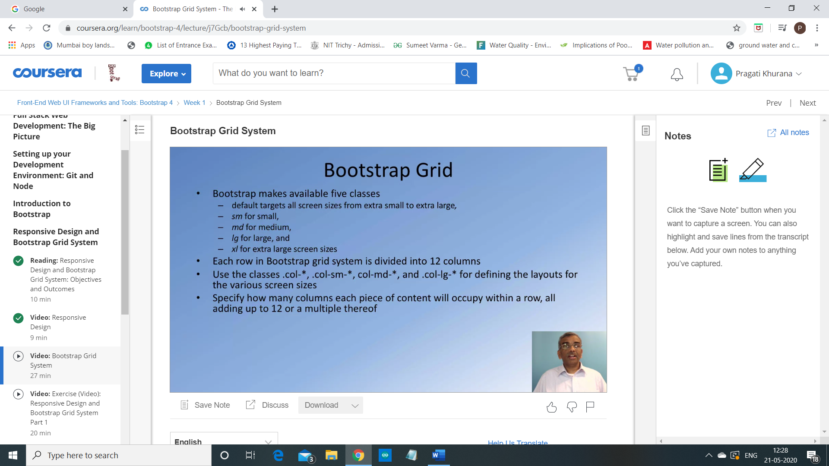

Now, we will layout content using what is called as the column classes.

For the column classes,

we can specify how the layout is done for different screen widths.

Now, we will layout content using what is called as the column classes.

For the column classes,

we can specify how the layout is done for different screen widths.

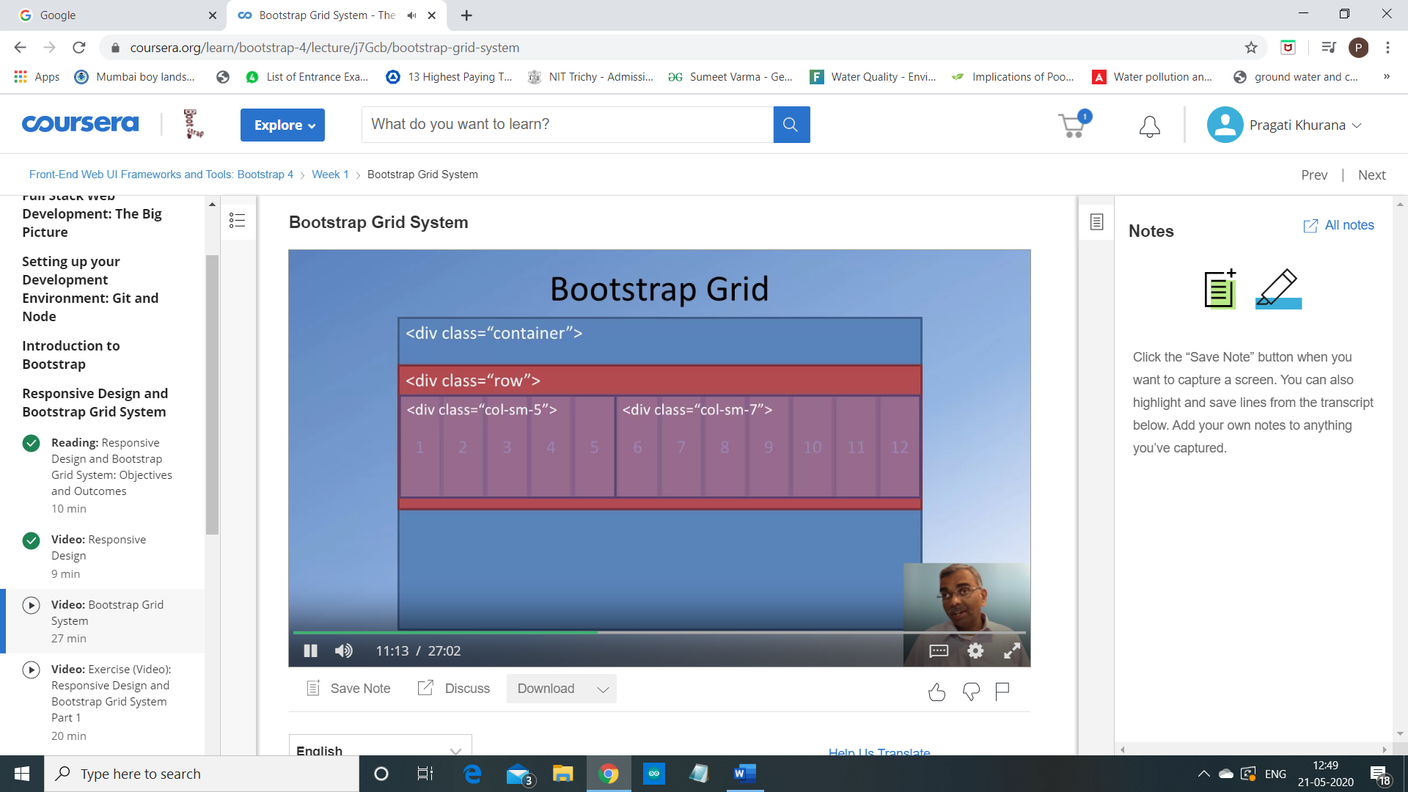

Now, in this case,

you see that 5 plus 7 is equal to 12.

So, these two pieces of content that are enclosed in the two divs,

will now be positioned side by side,

and the sum total of them is occupying the entire 12 column width.

So, this is how we can specify and the work with the 12 columns

in defining the layout of the current tier.

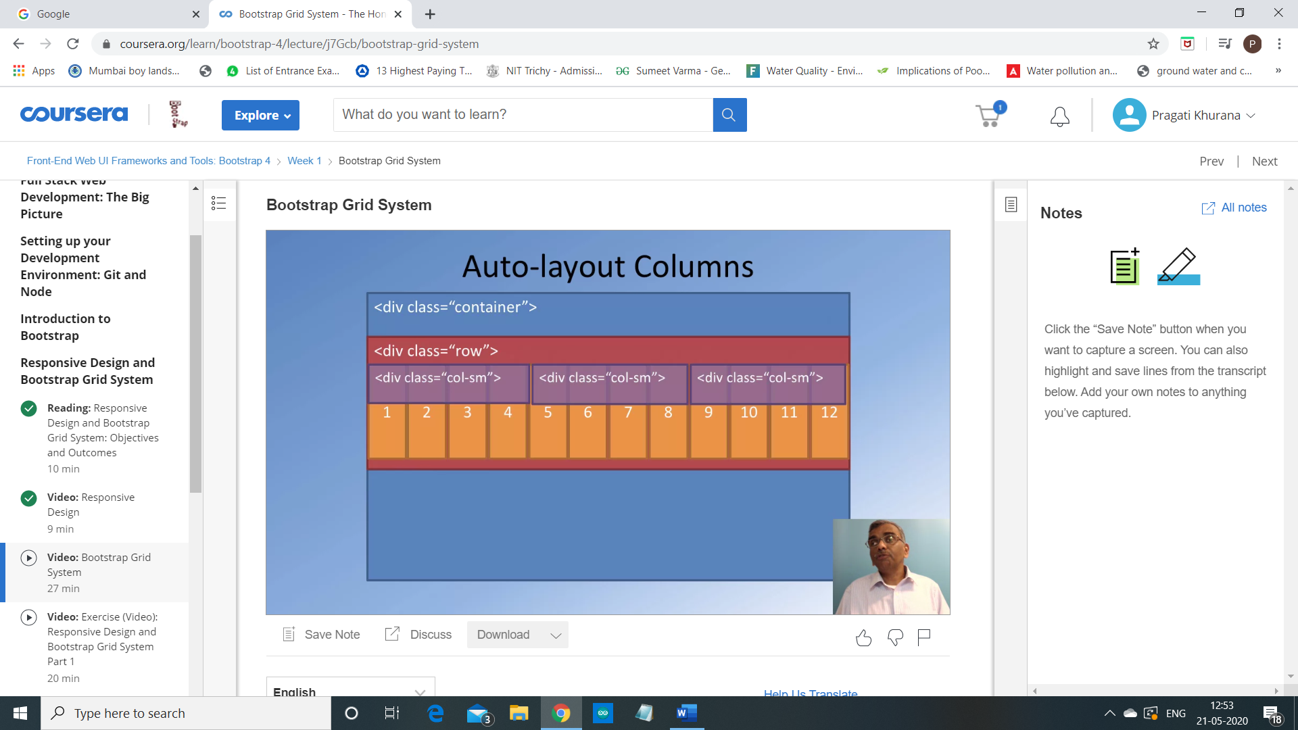

With the use of the CSS flex box layout,

Bootstrap also supports what is called the Auto-layout Columns.

So, in this case,

I can simply specify

column sm without specifying how many columns it is supposed to occupy.

But in case I specify three Doobs width column sm in my heml 5,

then the bootstrap grid will automatically position these contents inside those divs,

side by side, so,

that each one of them gets one third of the total width.

So, since we have 12 columns here,

each of these three will get four columns each.

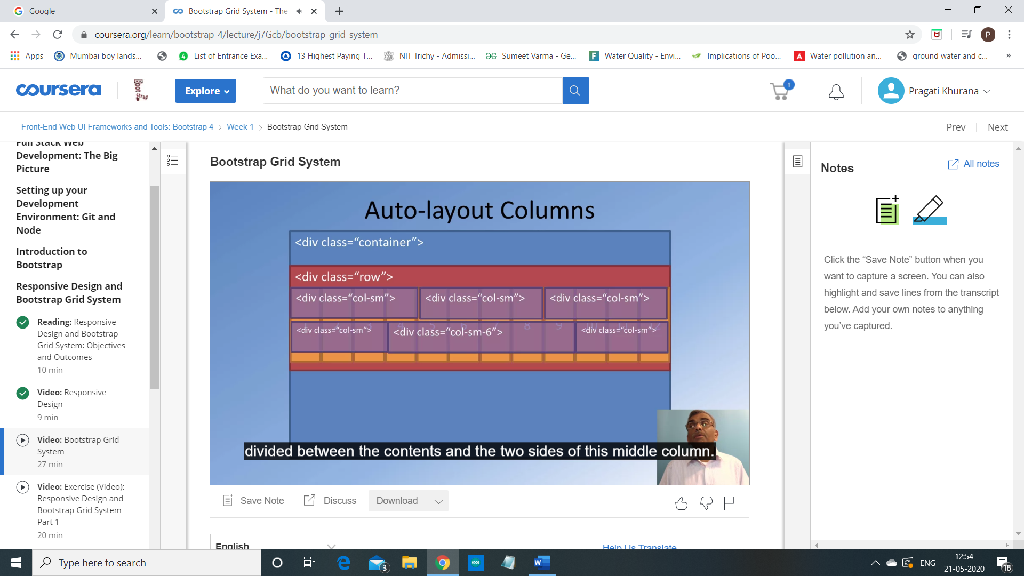

Now, we can explicitly specify

the number of columns a particular piece of content occupy.

So, for example, suppose I specify three column classes,

but the middle one I specify column sm 6.

Then what happens is, when bootstrap does the layout,

the middle one will occupy six columns,

and then the left and the right pieces of content will occupy whatever is left off.

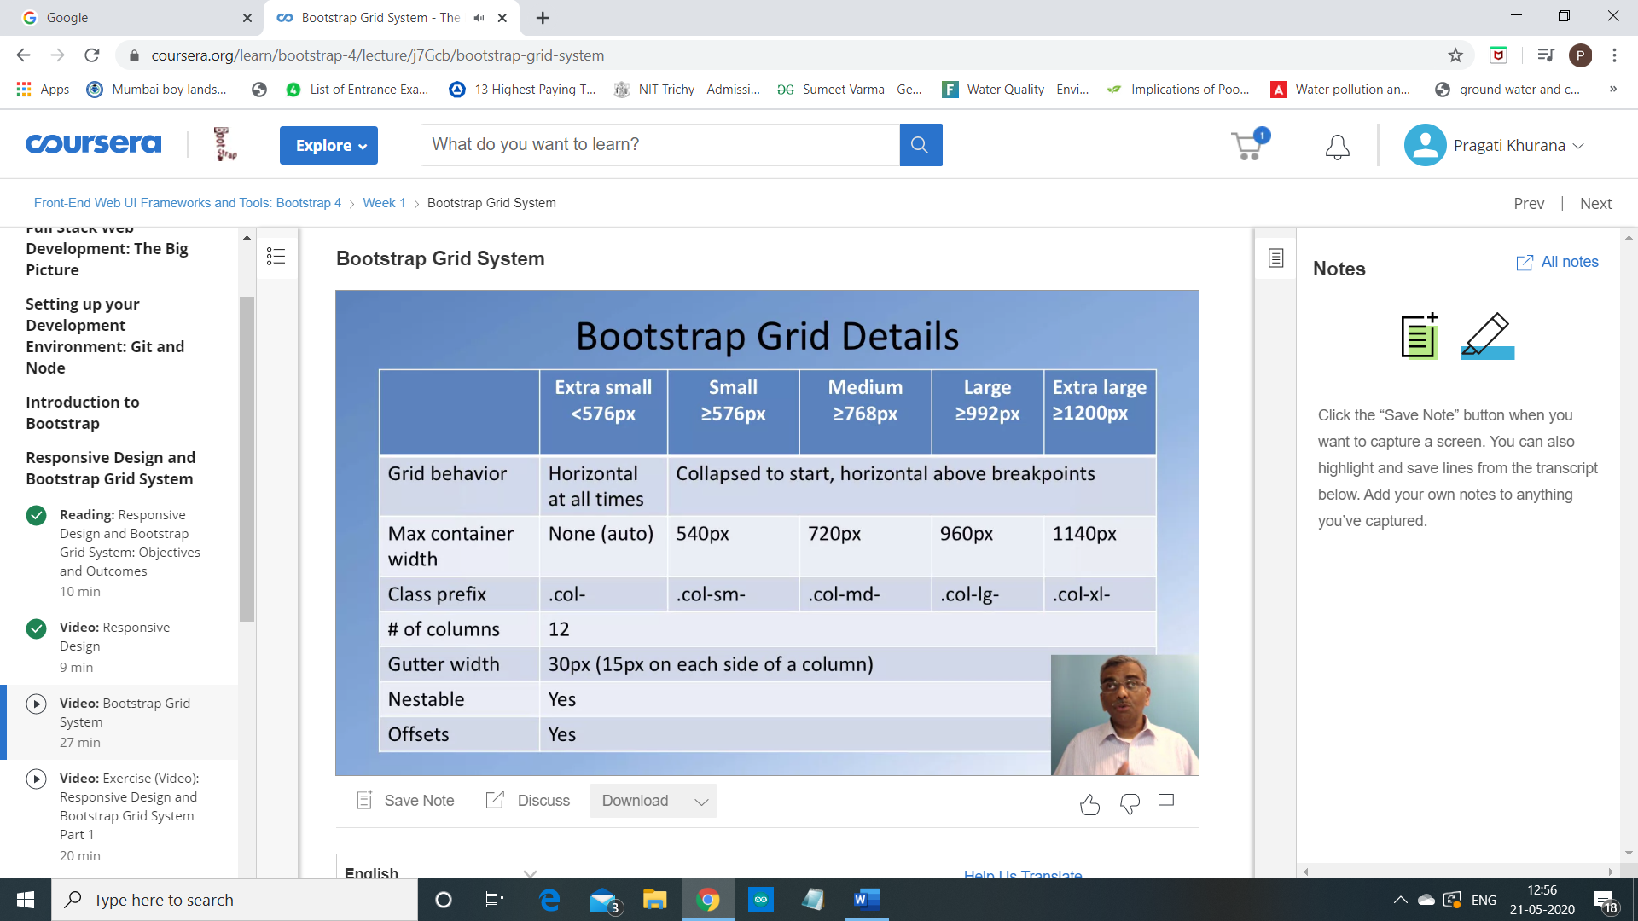

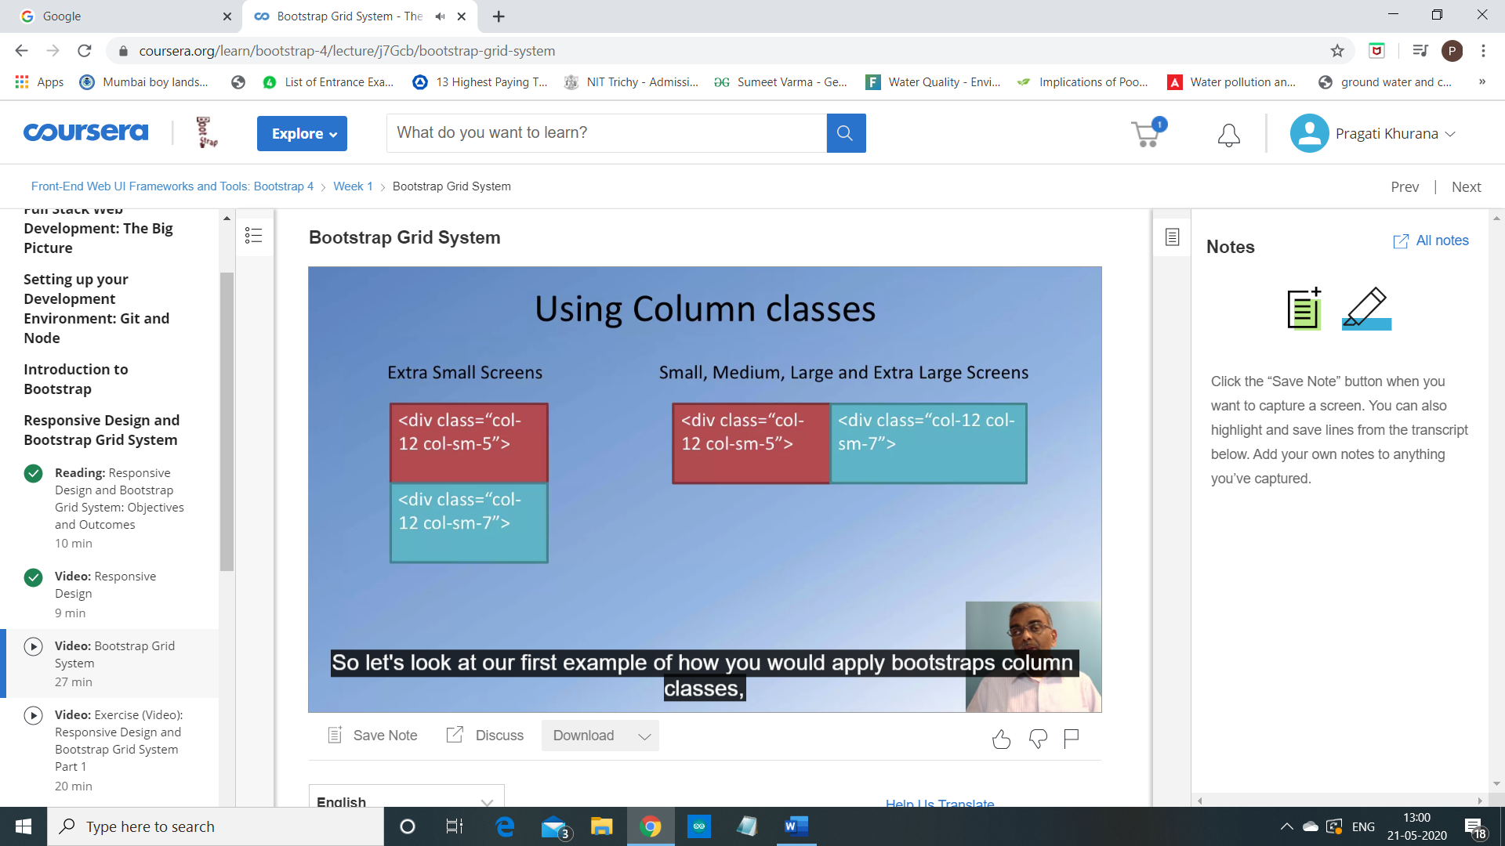

Bootstrap also provides additional classes called as

the Order Hyphen Classes which allow you to reorder the content on the screen.

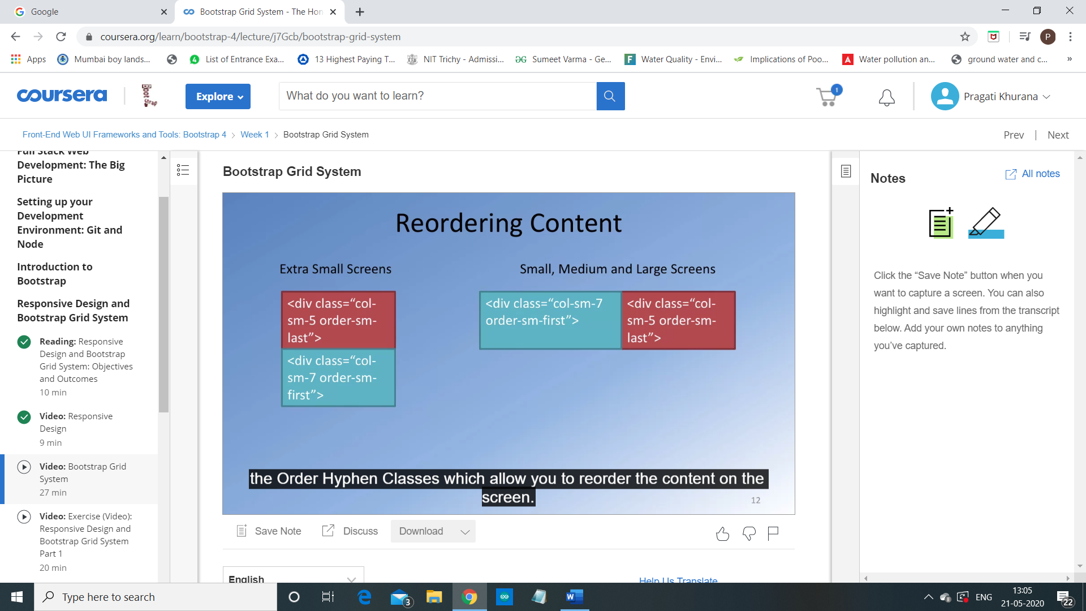

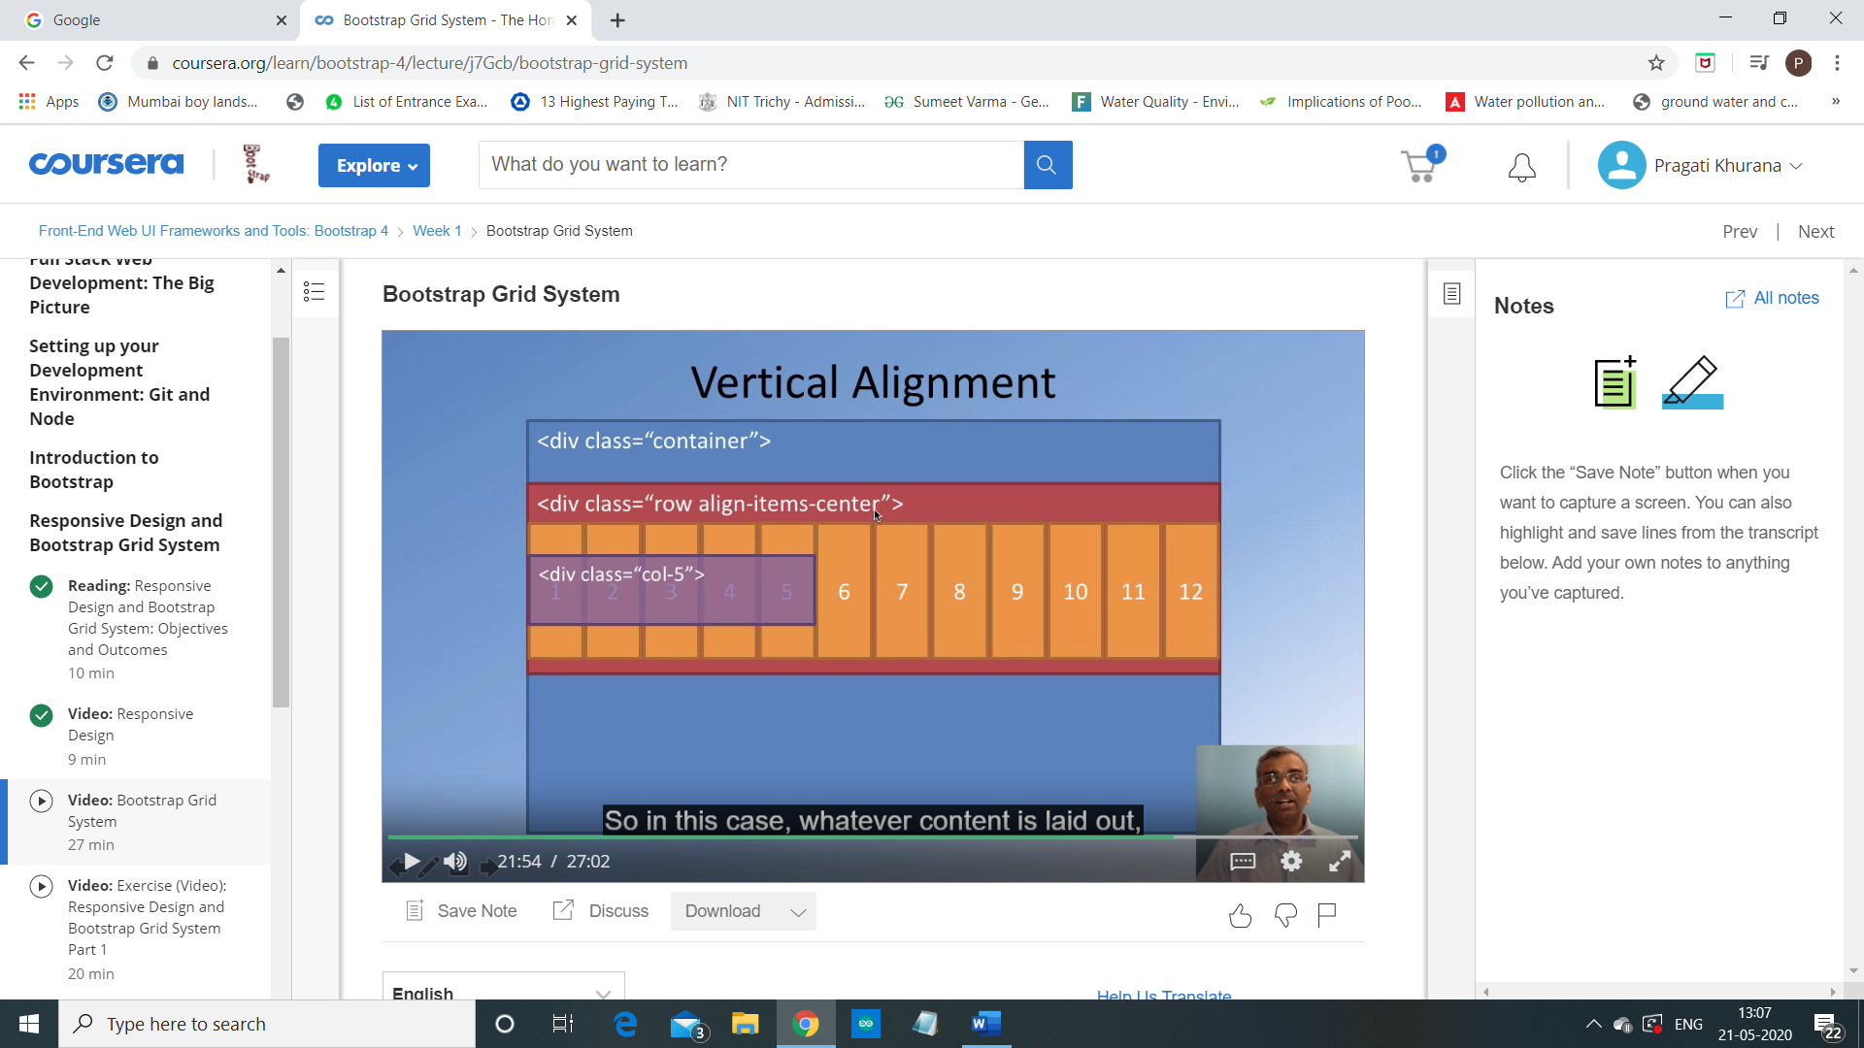

The earlier Bootstrap versions,

like Bootstrap 3 and earlier,

did not have the ability to do vertical alignment of content.

With the use of the Flexbox for designing the Bootstrap Grid in Bootstrap four,

we get the flexibility that CSS Flexbox brings in terms of doing vertical alignment.

So if you wanted the content to be vertically-centered,

then to the row,

you would apply the class called "align items center".

So in this case, whatever content is laid out,

will be laid out vertically-aligned within that particular row.

Not only that, Bootstrap's Grid also supports horizontal alignment of content. 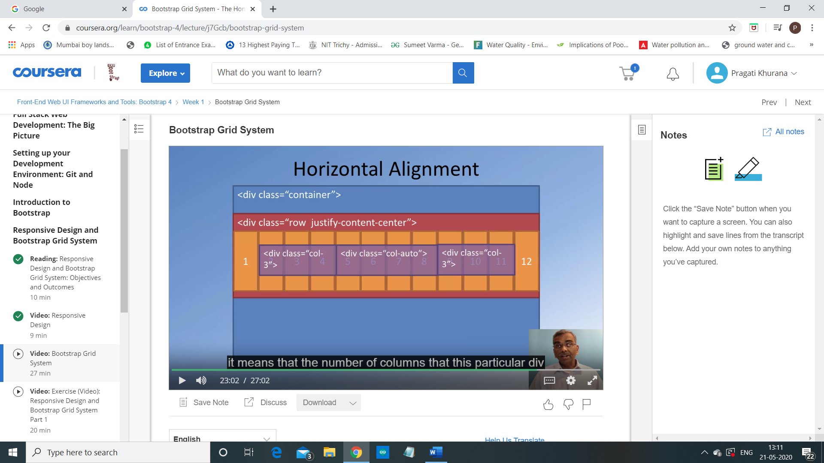

So based upon the content,

the number of columns occupied by the div will automatically adjust itself.

In this particular case, in this layout,

that particular content is being accommodated within four columns.

So now you have four columns being used by the center div,

three columns by the left and three columns by the right.

So sum total, you have 10 columns.

So you have two columns that are left empty.

Now, if you specify for the row,

you specify justify content center, then,

the entire content in this particular row will be centered with

respect to the row horizontal.

You can also have the content left-justified,

right-justified and a couple of other options.

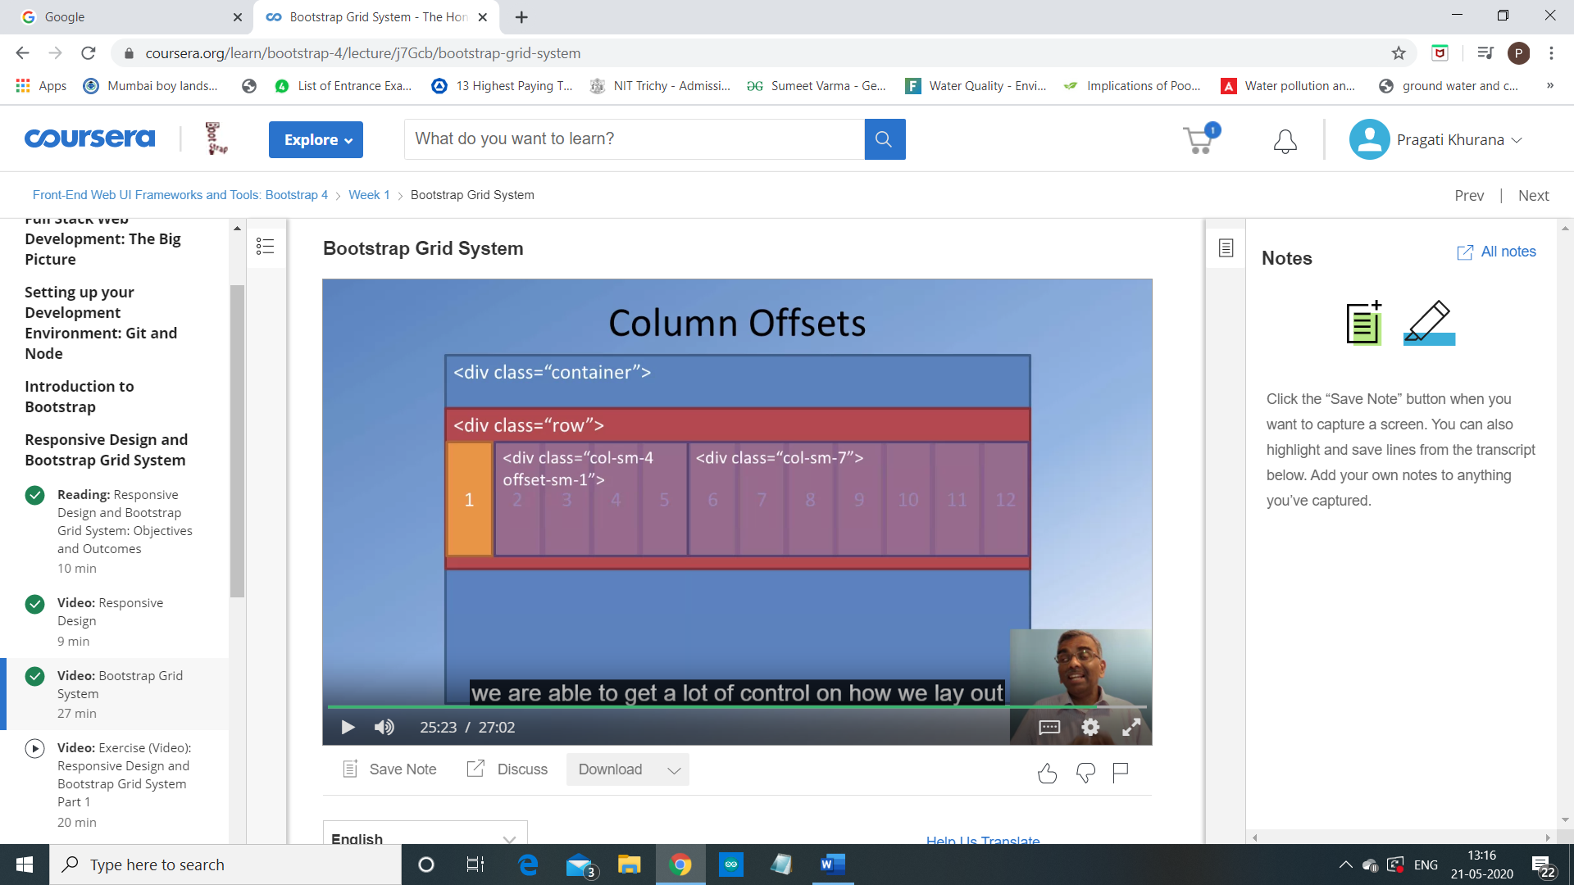

Bootstrap also allows you to do column offsets.

How does this work? Let's look at an example.

In this column offset,

we can specify a piece of content,

add to that if we apply the class as offset hyphen sm hyphen one.

What we are specifying is for small to extra large screens,

this piece of content should be right-shifted by one column.

So when this content is laid out, as you can see,

the leftmost one column is left blank and the content is shifted right by one column.

And you can layout the remaining content on the right side.

So sum total, you can see that the two divs will

occupy 11 columns but one column offsetted to the right.

